Driver Button Mapping (Feb 27, 2017)

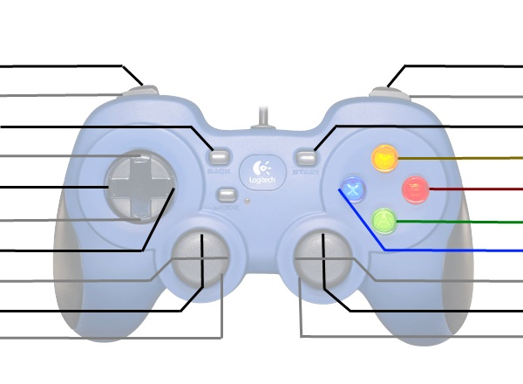

Drive Forwards

Left Fwd/Back

Shift Gears

Right Fwd/Back